Exploring new ways to reduce the energy used by artificial intelligence

How does the activation function used by a neural network affect the energy needed to train the model?

Activation functions that have a non-zero derivative for negative values will have less energy consumption than the standard ReLU function, because non-zero everywhere-differentiable functions allow the model to improve even when neurons have negative inputs.

*The activation function graphs can be found at
https://docs.pytorch.org/docs/stable/nn.html

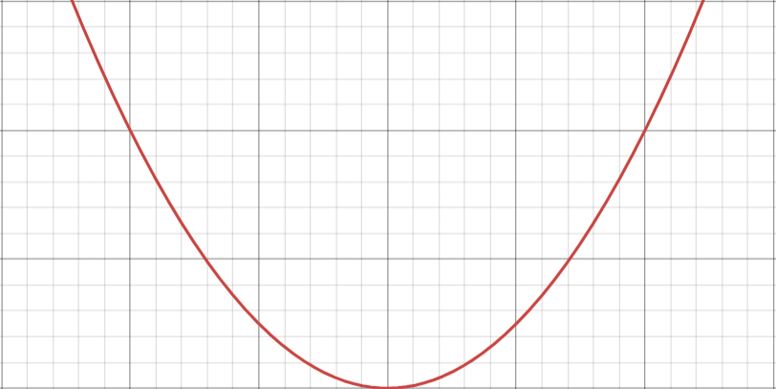
 | Average Energy  Consumption | Standard Deviation
ReLU | 23559.91699 | 5537.065495
Leaky ReLU | 21172.7223 | 3986.931094
GELU | 17244.01086 | 2867.626974
ELU | 22781.15658 | 4611.20588
SELU | 30699.63675 | 6062.956381

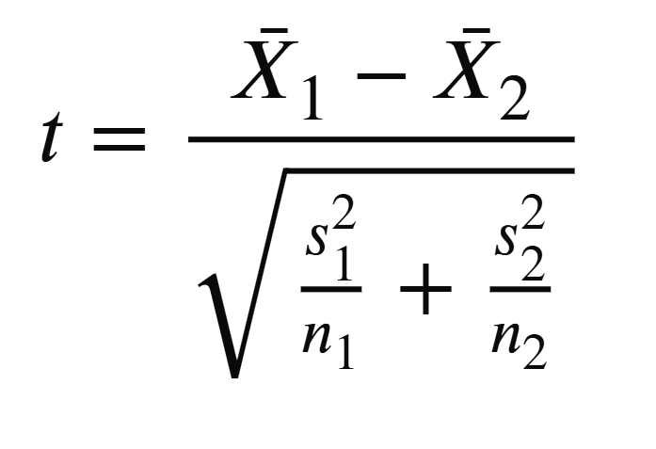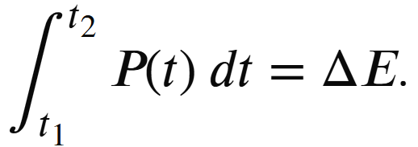
In graph 1, we can see that ReLU has a uniform distribution. Leaky ReLU, GELU, and ELU all have a smaller median than ReLU, while SELU performed worse. GELU has the smallest median value and spread, suggesting that it is the best function to use for achieving a consistently low amount of energy.

In Graph 2 it is easier to see the individual differences between each of the trials. Graph 3 shows the averages, but more work needs to be done to show if the differences are significantly different.

This project applies to the real world, because artificial intelligence companies can use this research to reduce the cost of training classification networks.

- Setup
  - Download python and install necessary libraries (PyTorch, matplotlib, mpmath, numpy, pandas, pillow, torchview, triton-xpu)
  - Install Libre Hardware Monitor and the experiment script and utilities
  - Split the data into a training batch and test batch
  - Place laptop in a controlled environment (constant cooling, power source, screen brightness etc)
  - Edit main.py so that training occurs 3 times per function, with a target accuracy of 80 percent
- Experiment
  - Launch Libre Hardware Monitor and begin logging sensor data
  - Run main,py, and wait for the program to finish (could take up to 8 hours)
  - Use predefined random seeds to ensure repeatability
  - Repeat steps 6-8 three times
- Obtaining Data
  - Remove duplicate seconds from the log file
  - Run strip_csv.py and format_data.py to extract the data we need
  - To get the amount of energy consumed during the training, use the trapezoidal sum to take the integral of the GPU power.
To find out if the activation function has a statistically significant difference in energy consumed, I performed a 2 sample t-test for population means on each of the activation functions. The test suggests that using the SELU and ELU activation function did not have a significant affect on energy consumption. Leaky-ReLU has a notable but not statistically significant result, while GELU has a p-value almost 10 times smaller than it needs to be to be statistically significant. The evidence supports our hypothesis that having a non-zero derivative can reduce the energy consumption used while training a model. To explain the poor performance of SELU compared to ELU despite their similarity, I propose this model:

The result of this experiment leaves more to be answered. What other factors go into energy consumption, and does statistically significant mean practically significant?

Some potential sources of error could be that we only measured a specific component for energy consumption, the GPU. We didn’t measure the cooling, CPU, or data transfer. Additionally, we had to approximate using the trapezoidal rule.

This project applies to the real world, because artificial intelligence companies can use this research to reduce the cost of training classification networks.

